**DL – Lab 3**

**7 )**



tharindu_image1 (Database Image)



tharindu_image2 (Test Image)

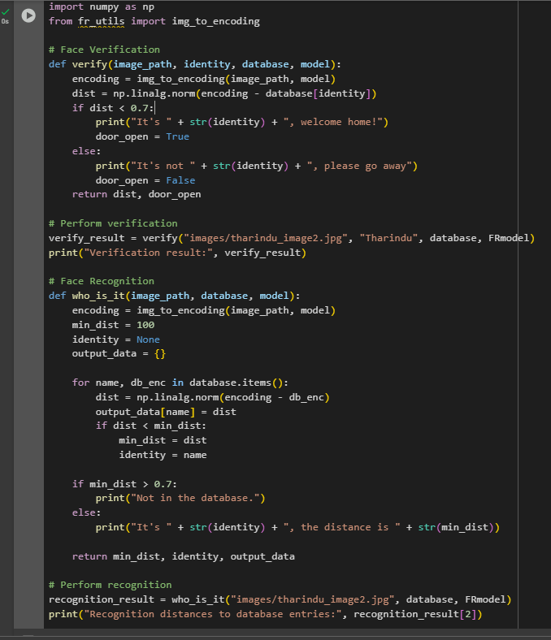

**8)**

It's Tharindu, welcome home!

Verification result: (np.float32(0.0), True)

It's Tharindu, the distance is 0.0

Recognition distances to database entries: {'danielle': np.float32(1.1319008), 'younes': np.float32(1.0086365), 'tian': np.float32(0.923947), 'andrew': np.float32(1.1057899), 'kian': np.float32(0.88443065), 'dan': np.float32(1.0389293), 'sebastiano': np.float32(0.9534882), 'bertrand': np.float32(1.0551345), 'kevin': np.float32(1.0082848), 'felix': np.float32(0.96786237), 'benoit': np.float32(0.90884584), 'arnaud': np.float32(0.983981), 'Tharindu': np.float32(0.0)}

